Feature Encoding Brief
One-Hot Encoding vs Label Encoding

1. Introduction
When I started working on the feature engineering pipeline for this task, one of the first problems I ran into was what do you do with columns that contain text instead of numbers? Columns like city names (New York, London, Paris) or gender (Male, Female, Unknown) cannot be processed by any machine learning algorithm in their raw text form.
This report explains why that is the case, what two main encoding methods exist to solve this problem, how they are mathematically different from each other, and most importantly what actually goes wrong when you skip encoding entirely and pass raw strings directly into a model.

2. The Core Problem
Every machine learning model whether it is a decision tree, a neural network, or a support vector machine works by doing math. It multiplies values, calculates distances between data points, adjusts weights, and computes predictions. All of these operations require numbers.
When a dataset has a column like city that contains the text value "New York", the model hits a wall. It cannot multiply "New York" by a weight. It cannot calculate the distance between "New York" and "London". It has no idea what these strings mean mathematically.
This is called the vector representation problem. Every data row needs to be represented as a vector a list of numbers so the model can process it. A row with Age=30, Income=50000, City=London looks like this to the model:
x = [ 30, 50000, ??? ]
The ??? is where the string London should go, and the model has no way to fill it in. This is not a minor inconvenience it is a fundamental blocker. The model either crashes or produces meaningless results.

3. What Actually Happens When You Feed Raw Strings

Three Ways It Fails
I tested what happens when raw strings are passed into a model without encoding. There are three possible outcomes, none of them good:

Immediate crash (most common):
Python's scikit-learn throws a TypeError and refuses to run. The error message says something like "could not convert string to float". The model never trains at all. This is actually the best-case failure because it is at least obvious.
Silent column drop:
Some frameworks silently ignore string columns and train on whatever numerical columns remain. The model appears to work but has been trained on incomplete data. There is no warning you only discover this later when you notice certain features are missing from the model's understanding.
Arbitrary memory address assignment:
In some older tools, Python assigns the memory address of each string object as its integer value. The string "New York" might get the value 140234567 and "London" might get 140234891. These numbers are completely random, change every time the script runs, and have no relationship to each other. The model trains on pure noise.

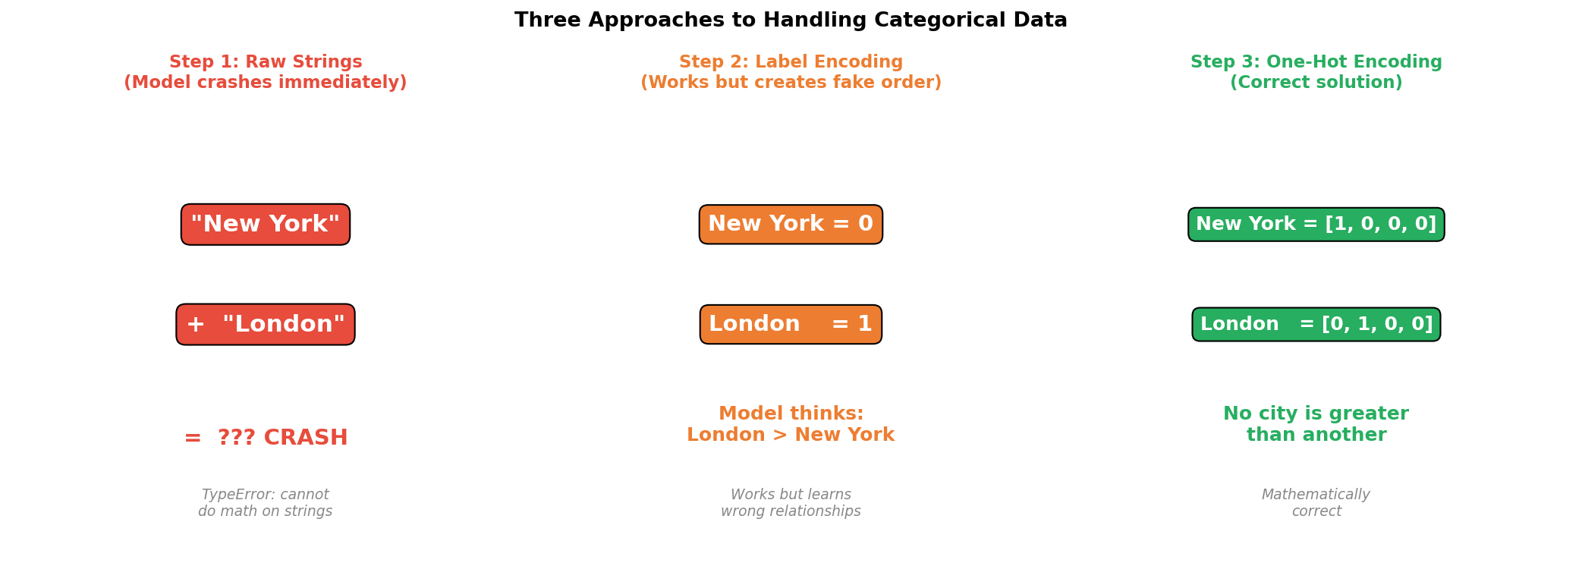

4. Label Encoding
Label Encoding is the simpler of the two encoding methods. It looks at all the unique values in a column and assigns each one a unique integer. The assignment is usually alphabetical or based on the order values appear in the dataset.
For a city column with four cities, the encoding looks like this:
New York = 0 London = 1 Paris = 2 Tokyo = 3
The original text column is replaced with these integers, and the model can now process the column mathematically.

Problem
Here is where Label Encoding goes wrong for nominal data (categories with no natural order). The moment you replace city names with integers 0, 1, 2, 3, you have introduced an ordinal relationship that does not exist in reality.
The model now treats the city column as if it were a scale, just like age or income. It learns that:
- Tokyo (3) is three times greater than New York (0)
- The difference between London (1) and Tokyo (3) is twice the difference between London (1) and New York (0)
- New York + Paris = Tokyo, because 0 + 2 = 2... wait, that is not even Tokyo, that is Paris
None of this makes any sense. Cities have no mathematical relationship to each other. Label Encoding invented one, and now the model will learn it as if it were real. This corrupts the model's understanding of the data.

When Label Encoding Is Actually Correct
Label Encoding is not always wrong. It is the right choice when the categories genuinely have a meaningful order. These are called ordinal variables:
- Education level: No Degree=0, Bachelor=1, Master=2, PhD=3, this order is real and meaningful
- Customer satisfaction: Poor=0, Fair=1, Good=2, Excellent=3, this order reflects actual quality levels
- T-shirt size: Small=0, Medium=1, Large=2, XL=3, this order reflects actual size progression
For these variables, the integer ordering reflects a real world relationship, and Label Encoding correctly captures it. The rule is simple: if you can say one category is genuinely greater or higher than another, Label Encoding is fine. If the categories are just different names with no inherent rank, use One-Hot Encoding.

5. One-Hot Encoding

What It Does
One Hot Encoding takes a completely different approach. Instead of assigning a single integer to each category, it creates a brand new binary column for every unique category. Each row gets a 1 in the column that matches its category, and a 0 everywhere else.
For the city column with four cities, the transformation produces four new columns:
New York → city_NewYork=1, city_London=0, city_Paris=0, city_Tokyo=0
London → city_NewYork=0, city_London=1, city_Paris=0, city_Tokyo=0
Paris → city_NewYork=0, city_London=0, city_Paris=1, city_Tokyo=0
Tokyo → city_NewYork=0, city_London=0, city_Paris=0, city_Tokyo=1

Each city is now represented as a vector where exactly one position is active (1) and all others are inactive (0). This is where the name One Hot comes from one position is hot (active) and the rest are cold.

Why This Is Mathematically Correct
The key property of One-Hot Encoding is that all categories are now equidistant from each other. To prove this, I can calculate the Euclidean distance between any two cities in the encoded space:
Distance(New York, London) = √((1-0)² + (0-1)² + (0-0)² + (0-0)²) = √2 ≈ 1.414
Distance(New York, Paris) = √((1-0)² + (0-0)² + (0-1)² + (0-0)²) = √2 ≈ 1.414
Distance(New York, Tokyo) = √((1-0)² + (0-0)² + (0-0)² + (0-1)²) = √2 ≈ 1.414
Every city is exactly √2 away from every other city. No city is treated as closer, farther, greater, or lesser than another. The encoding correctly represents the fact that these are simply different, independent categories with no mathematical relationship between them.

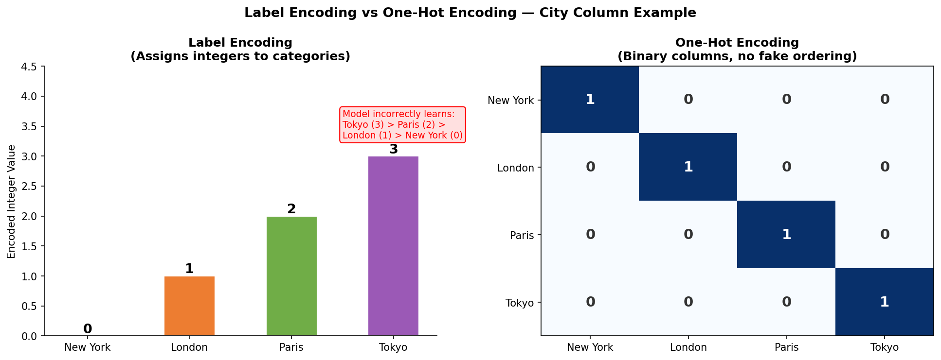

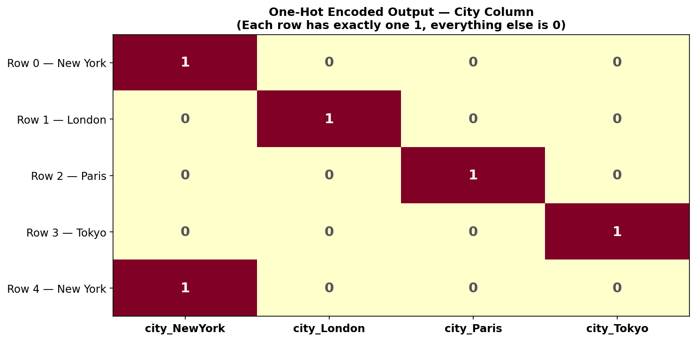

6. Mathematical Comparison
Property | Label Encoding | One-Hot Encoding
What it produces | One integer column | N binary columns (one per category)
Ordinal assumption | Yes, implies London > New York | No
Mathematical distance | Unequal between categories | Always equal
Memory | Very small | Larger
Best for | Ordinal data: size, grade, level | Nominal data: city, color, gender
Risk | High for nominal data | Low (except high-cardinality columns)
Used in this pipeline | On gender (for demonstration) | On both gender and city

7. Dummy Variable Trap
When I first learned about One-Hot Encoding, I did not realize there is a hidden problem called the dummy variable trap. It took me a while to understand why it matters.
The problem is if a column has 4 categories and you create 4 binary columns, the fourth column is always perfectly predictable from the first three. For example, if city_NewYork=0, city_London=0, city_Paris=0 then city_Tokyo must be 1. The fourth column contains zero new information.
In linear models, this perfect predictability causes a mathematical failure during training. The model needs to invert a matrix (find its inverse) as part of the learning process. When one column is perfectly predictable from others, that matrix becomes singular it has no inverse and the calculation crashes or produces infinitely large weights.
The fix is simple: drop one column. With N categories, you only need N-1 binary columns to represent all the information. In Pandas, this is done by adding drop_first=True:
pd.get_dummies(df, columns=['city'], drop_first=True)
It is worth noting that tree based models like Random Forest and XGBoost are not affected by this problem. Only linear models, logistic regression, and standard neural networks need the dropped column.

8. How This Was Applied in the Pipeline
In the feature engineering script I wrote for this task, both encoding methods were implemented using fully vectorized Pandas operations no for-loops anywhere.

Label Encoding was applied to the gender column using .map() to show how it works:
df['gender_label'] = df['gender'].map({'Male': 0, 'Female': 1, 'Unknown': 2})
This was included purely for demonstration. In a real production pipeline, gender has no natural ordering (Male is not greater than Female), so One Hot Encoding would be the correct choice.
One Hot Encoding was applied to both gender and city using pd.get_dummies():
df = pd.get_dummies(df, columns=['gender', 'city'], dtype=int)
This expanded the dataset from 4 columns to 16 columns, 3 new binary columns for gender (Male, Female, Unknown) and 4 new binary columns for city (New York, London, Paris, Tokyo). The original text columns were automatically removed and replaced with the binary columns.

9. Summary and Key Takeaways
After working through this topic, here are the key things I learned:
- Raw strings cannot go into a model, the model will crash or silently fail. Encoding is not optional.
- Label Encoding is fast and simple but it invents a fake ordering. Only use it when the categories genuinely have a natural rank, like education levels or satisfaction ratings.
- One Hot Encoding is the mathematically correct choice for nominal categories. It ensures every category is treated equally by making all inter-category distances identical (√2).
- The dummy variable trap is a real problem for linear models. Always drop one column (drop_first=True) unless using tree based algorithms.
- The encoding decision directly affects what the model learns. Getting it wrong does not produce a small accuracy drop, it teaches the model completely wrong relationships.

Data Type | Example | Correct Encoding
Nominal (no order) | City, gender, color, country | One Hot Encoding
Ordinal (has order) | Education level, satisfaction, size | Label Encoding
Raw string (no encoding) | Any text column directly in model | Always fails, crash or garbage output
High cardinality (1000+ values) | Zip codes, product IDs | Target Encoding or Embeddings
Prepared by: Izza Ibrar | 05 June 2026

